

Faculty of Computers and Artificial Intelligence

Computer Science Department

2022/2023

**CS 396 Selected Topics in CS-2**

**Research Project**

Report Submitted for Fulfillment of the Requirements and ILO’s for Selected Topics in CS-2 course for Fall 2021

Team ID No. 48

|  |  |  |  |
| --- | --- | --- | --- |
|  | ID | Name | Grade |
|  | 201900443 | عبدالرحمن ياسر حسانين ابراهيم |  |
|  | 201900424 | عبدالرحمن علي سعد علي |  |
|  | 201900456 | عبدالله السيد محمد على |  |
|  | 201900405 | عبدالرحمن اشرف عبده |  |
|  | 201900428 | عبدالرحمن مجدي عفيفي |  |
|  | 201900421 | عبدالرحمن عبدالناصر حسن |  |
|  |  |  |  |

Delivered to:

**Dr. Wessam El-Behaidy**

**Eng. Salma Doma**

**Eng. Ahmed Nady**

* **Paper Details**

# Paper Name: **An Introduction to Convolutional Neural Networks**

year of publication : 2015

* **Project Description**

# **Datasets for it** :[**good**](https://www.kaggle.com/datasets/masoudnickparvar/brain-tumor-mri-dataset?resource=download) **guys and bad guys**

Link : https://www.kaggle.com/datasets/gpiosenka/good-guysbad-guys-image-data-set

dimension of images = 128*128px

* **Implementation details**

## **Training (**2 directories ,7854) 69.95%

* savory
* unsavory

## **Testing (**2 directories ,3366) 30%

* savory
* unsavory

## **Validation (**2 directories ,600) .05%

* savory
* unsavory
* **Our Model**

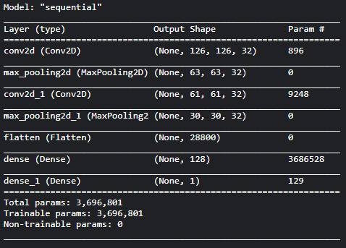

**Hyperparameters and architectures tested before reaching the final model**

**Pooling Layers : Max pooling**

**Learning rate : .01**

**Optimizers : Adam**

**No.epochs : 50**

**Image size : 128 x 128**

* **Testing results**

**When we use Adam Optimizer:** 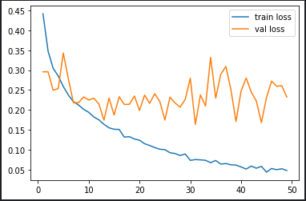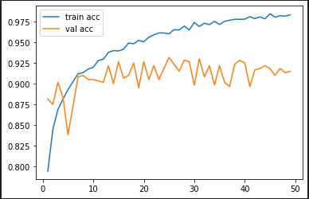

**Accuracy: 95.4 %**

